**ANGULAR PROJECT ---- KESAVA KUMAR**

***Home Page with Carousel***

(1)

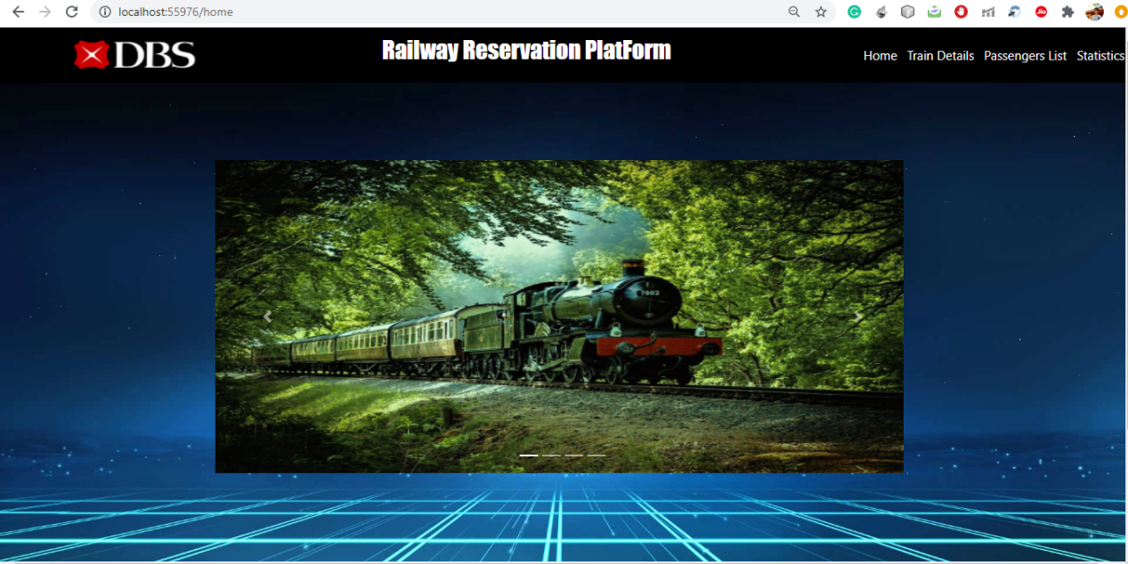

(2)

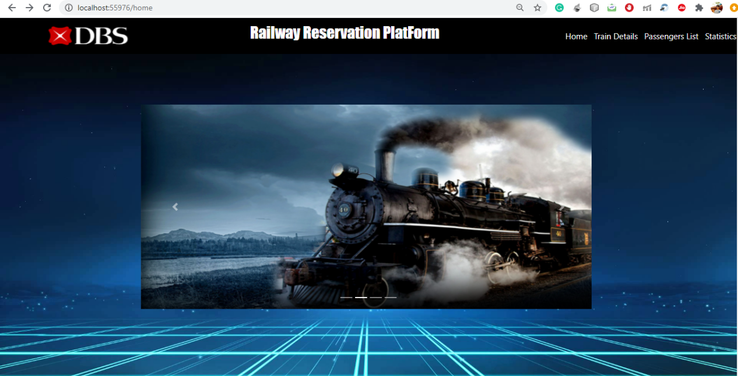

(3)

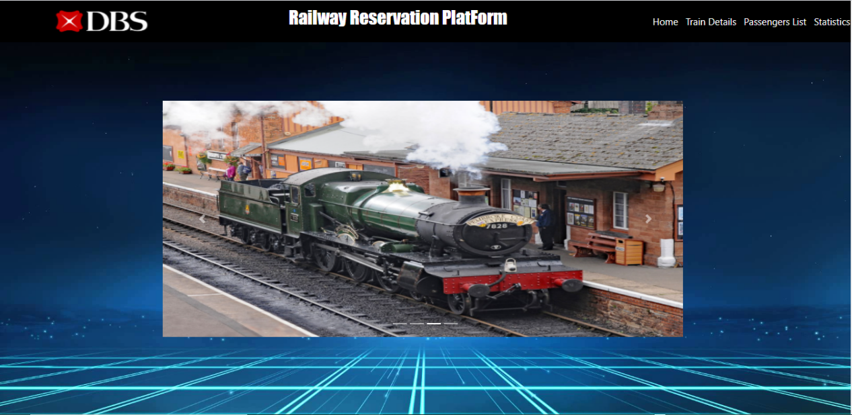

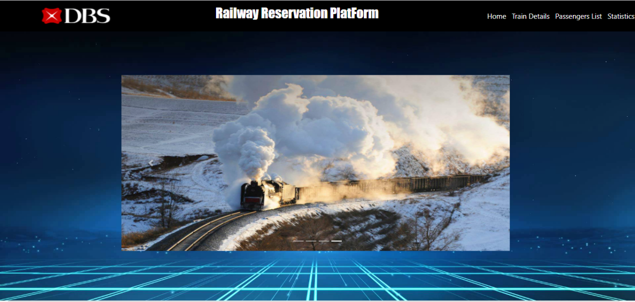

***TRAIN DETAILS***

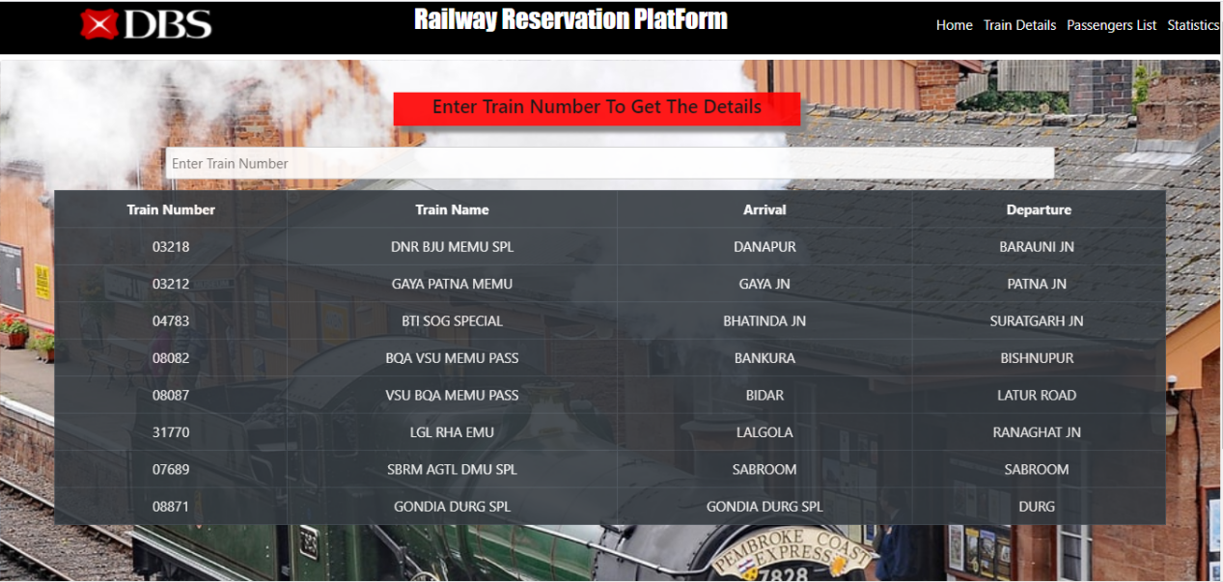

***TRAIN DETAILS BY FILTERING***

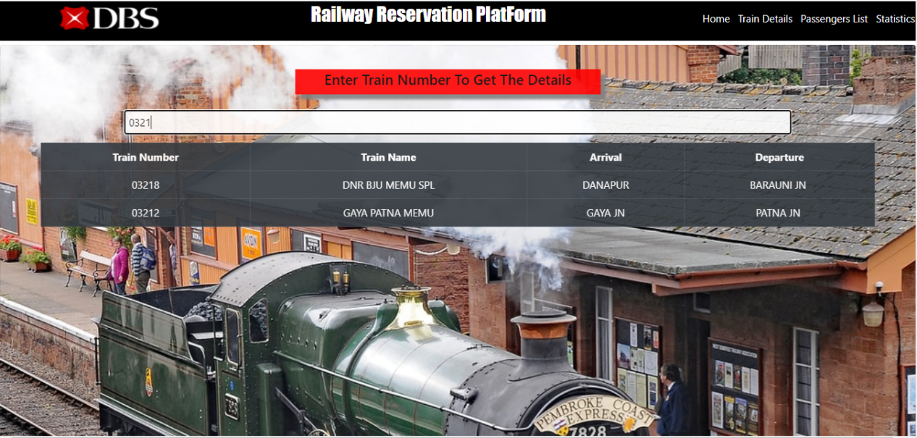

***PASSENGERS DETAILS***

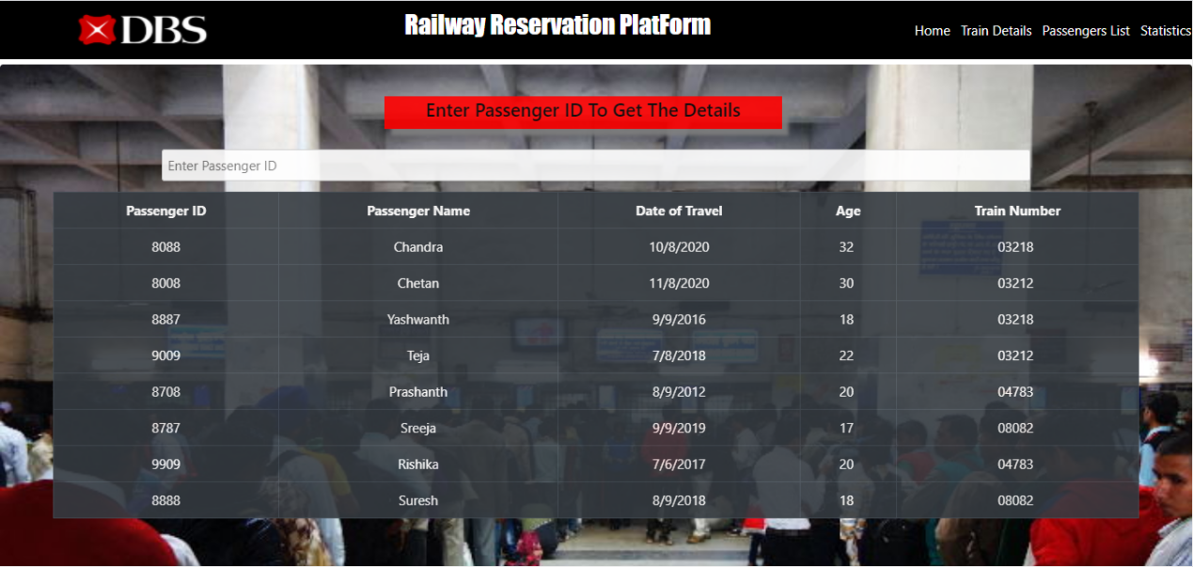

***PASSENGERS DETAILS BY FILTERING***

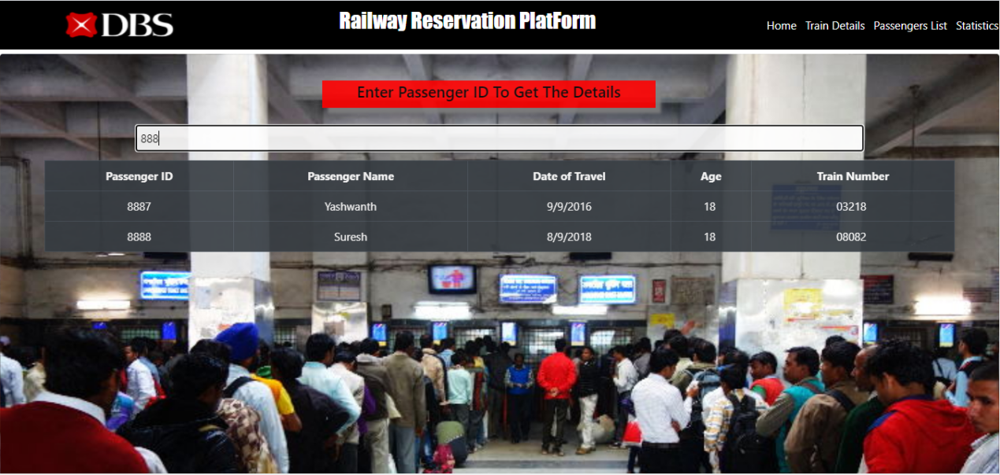

***STATISTICS***

Click on “Statistics” on Nav Bar

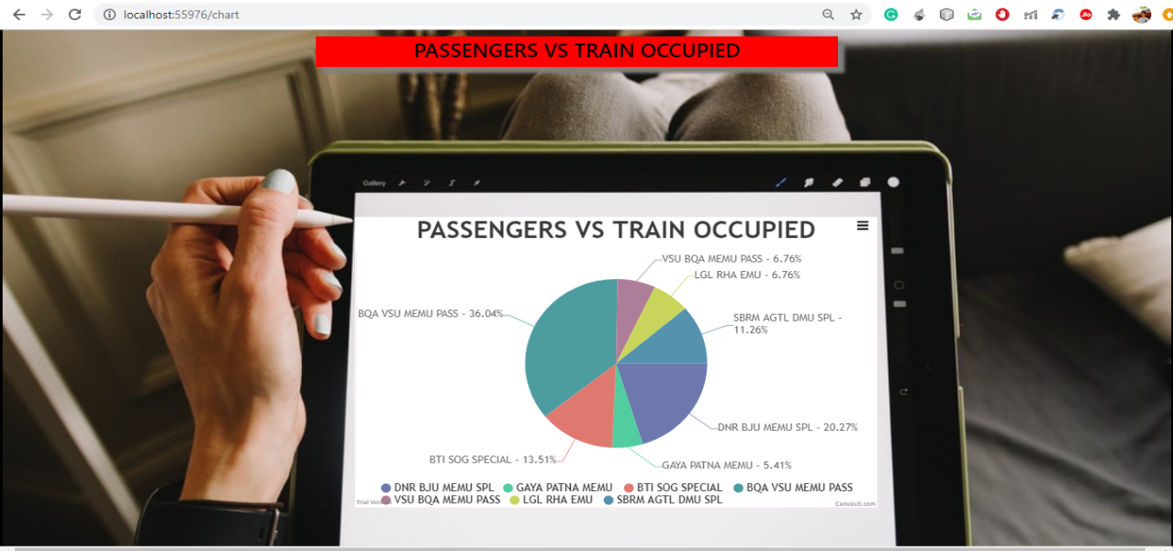

Click on 3lines that appear on the visualization chart to enable the print option

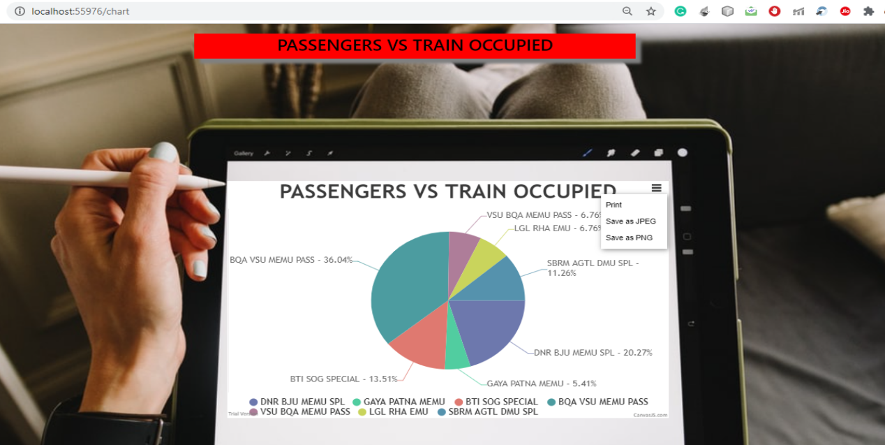

Click on Print Option to save the Visualization

